SQL

- By selecting *, this shows all the fields and records in table
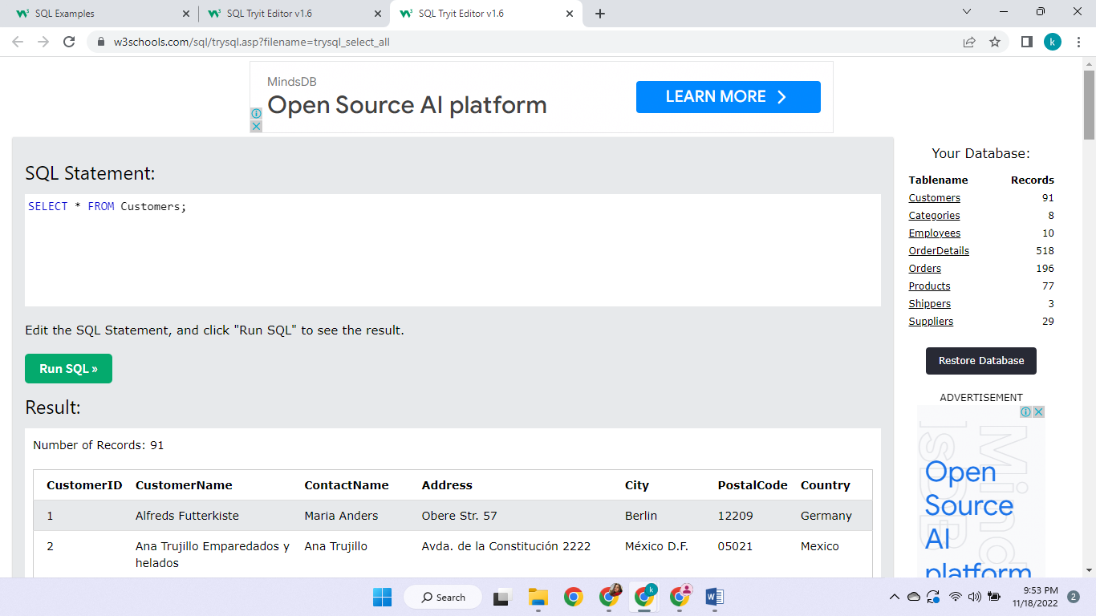

- This displays only the selected columns of the table
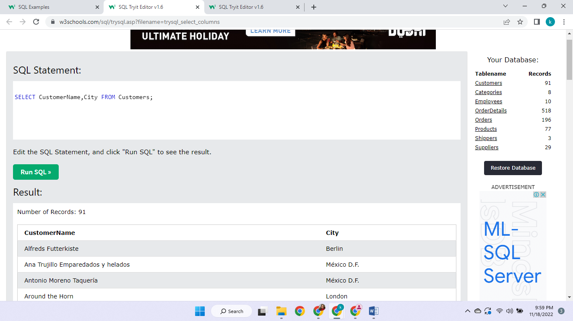

- This is showing all the countries’ name just once or displaying all the different entries
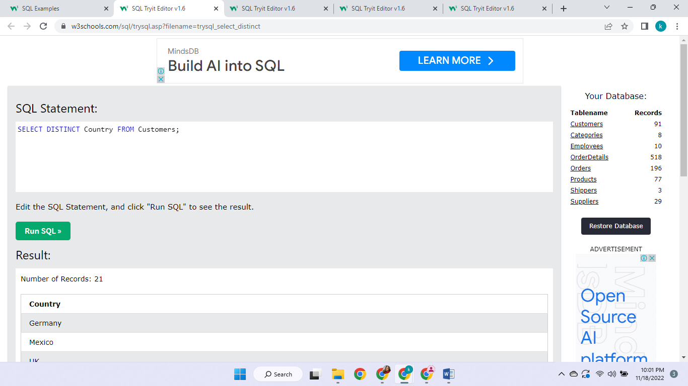

4.This is showing the number of all the countries listed
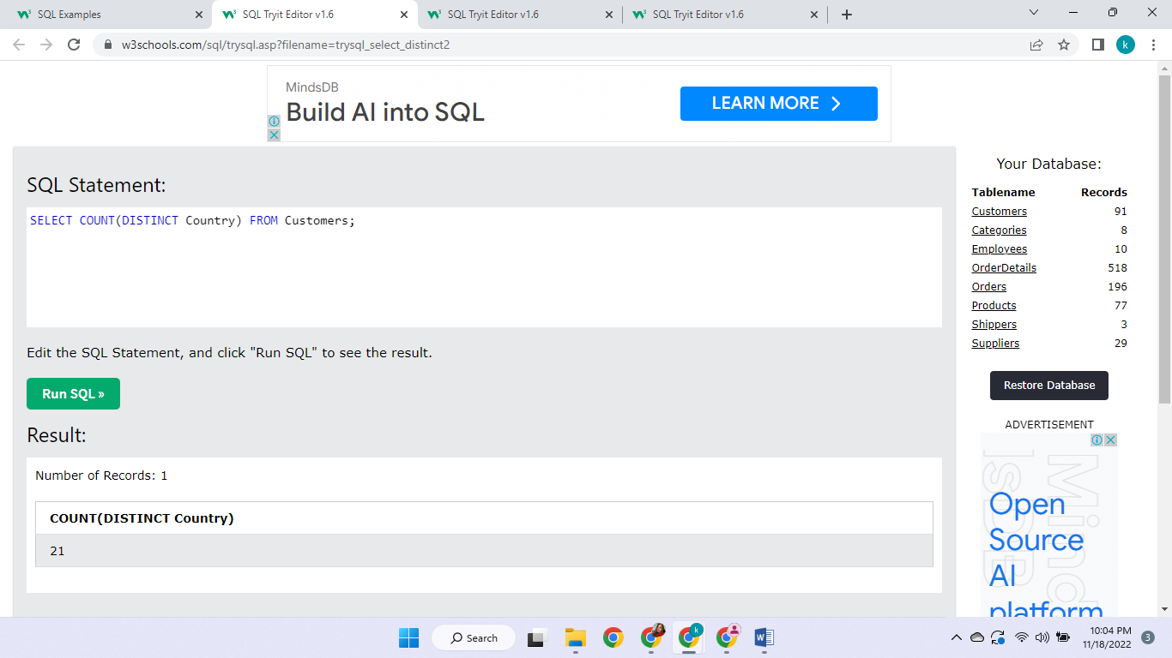

5. This is showing all the records related to mexico
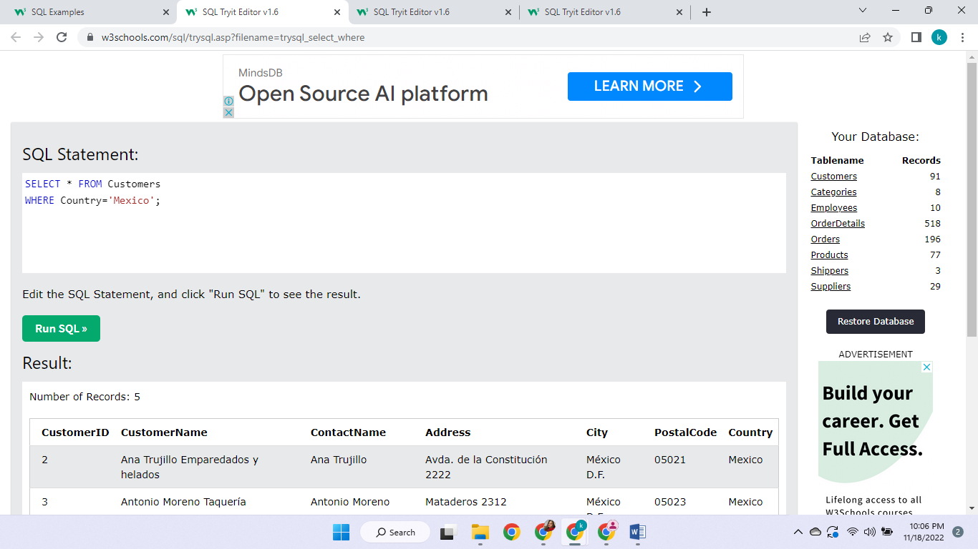

- This is showing that record with customer id 1 (unique)
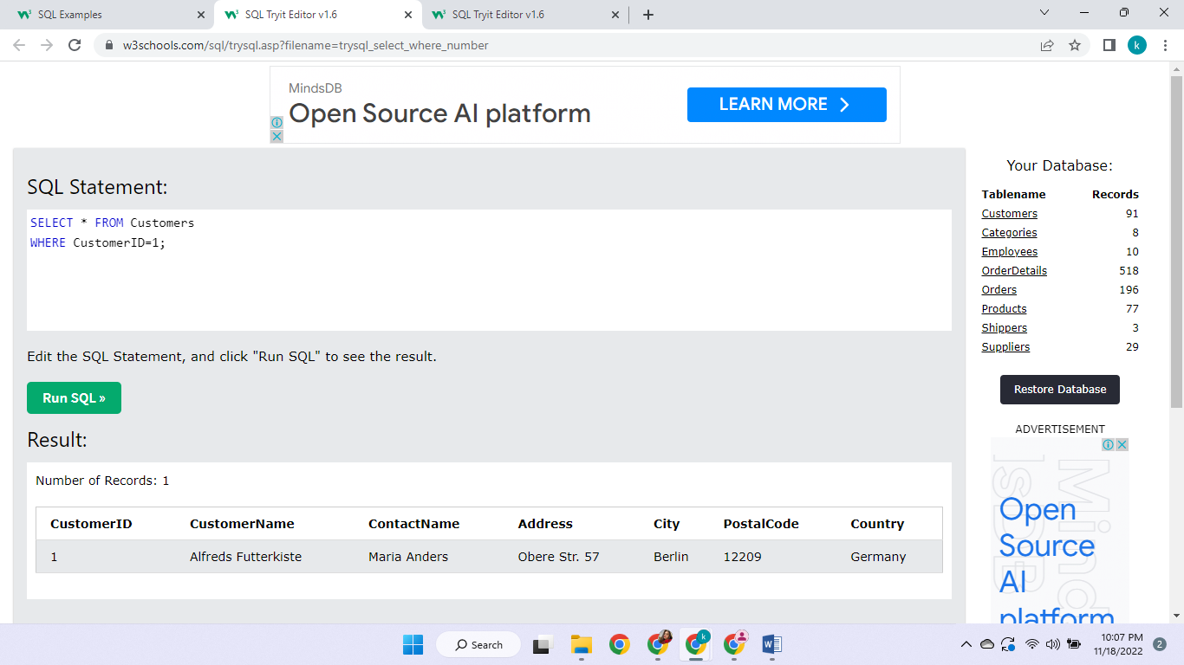

7. This is displaying records that have country selected: Germany AND city selected: Berlin
For this, both the conditions should be met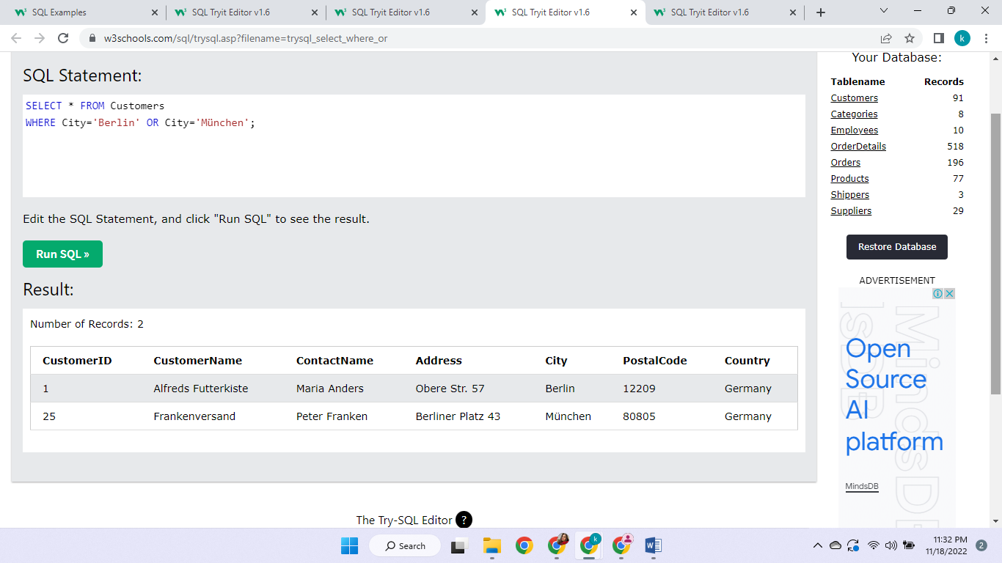

8. This is displaying records that have city selected: München OR city selected: Berlin
For this, any of the condition should be met

9. This is selecting all the records except for that one in which the country is Germany
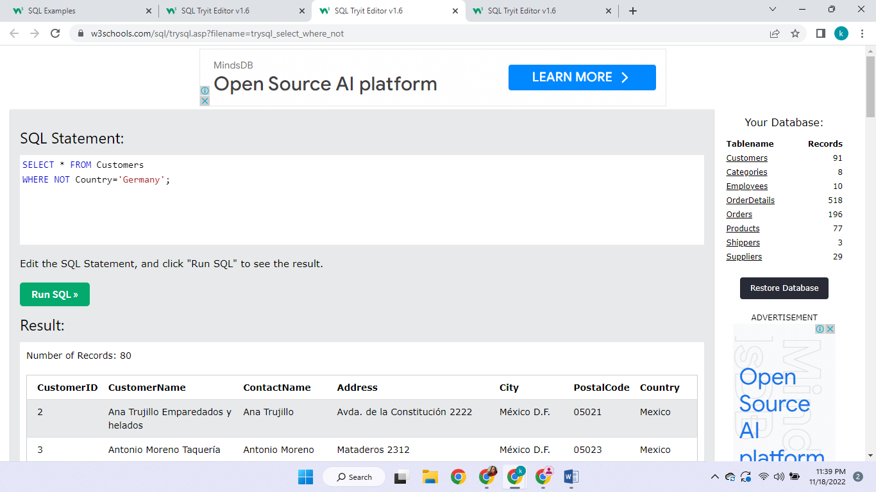

10.This is a combination of AND and OR
The country selected should be Germany AND
Either the city is Berlin or it can be München
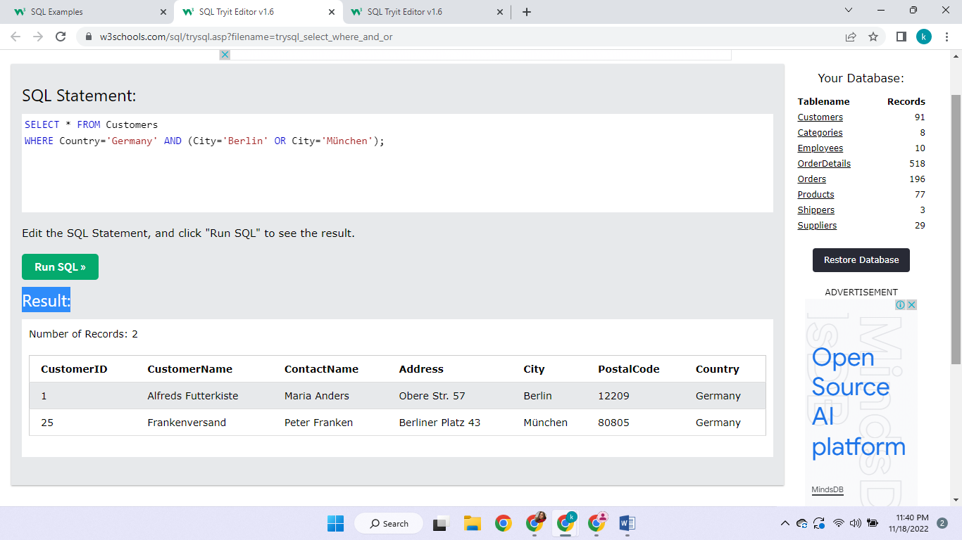
11. This is listing the records in a way that the countries’ name is in alphabetical order (A to Z)
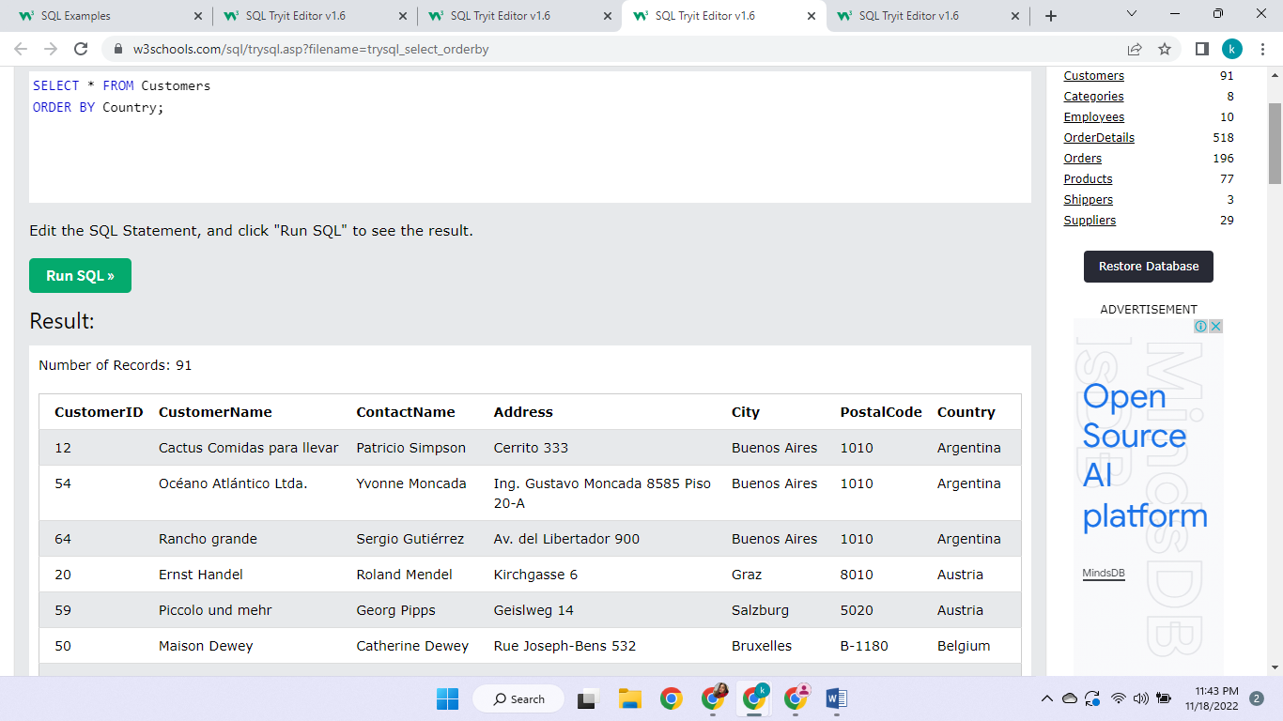

12. This is listing the records in a way that the countries’ name is in descending alphabetical order (Z to A)

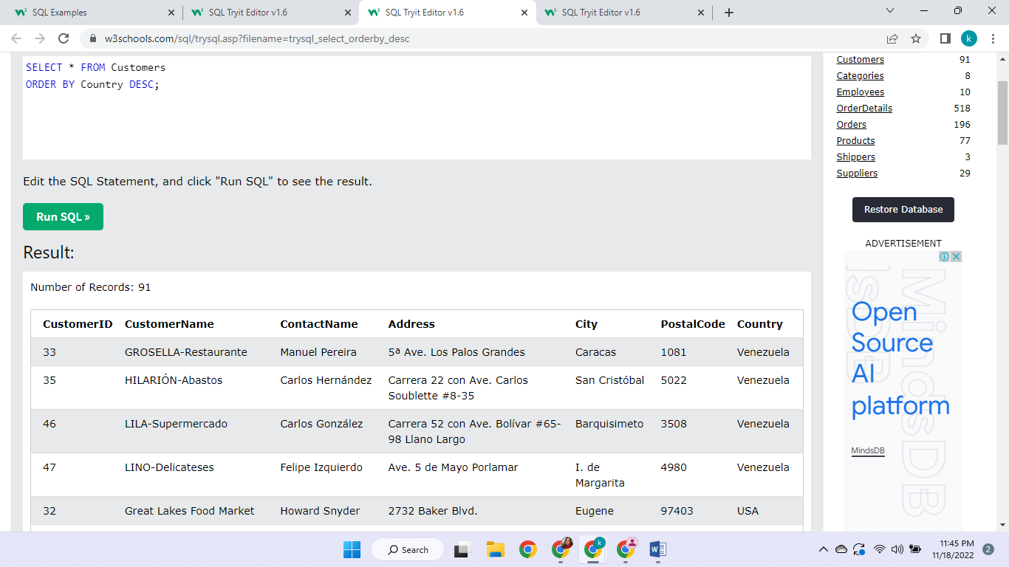
13. This is displaying records first ascending in country then next ascending in customer name
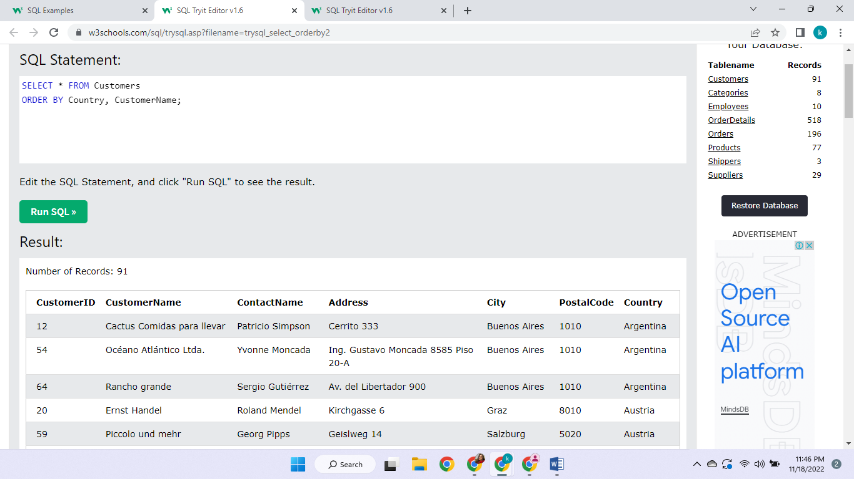

14. By inserting this, it just added another row in our database only in certain columns with these values
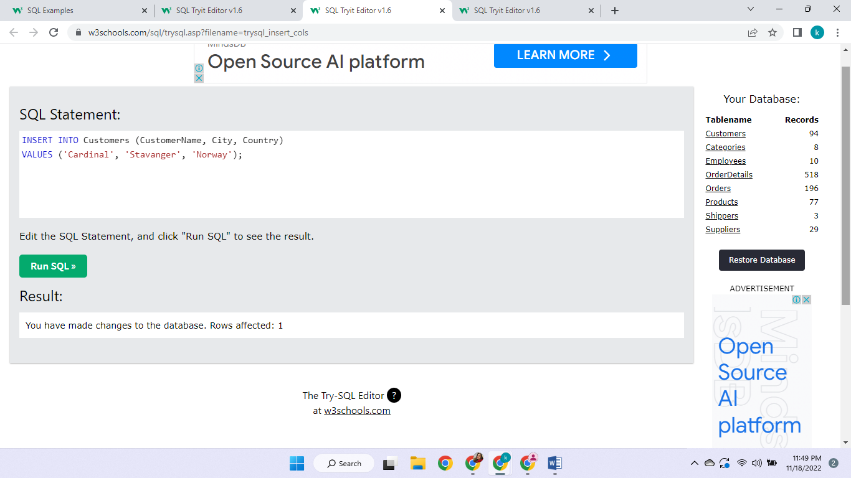

15. This inserts and fills up a complete row in all the columns
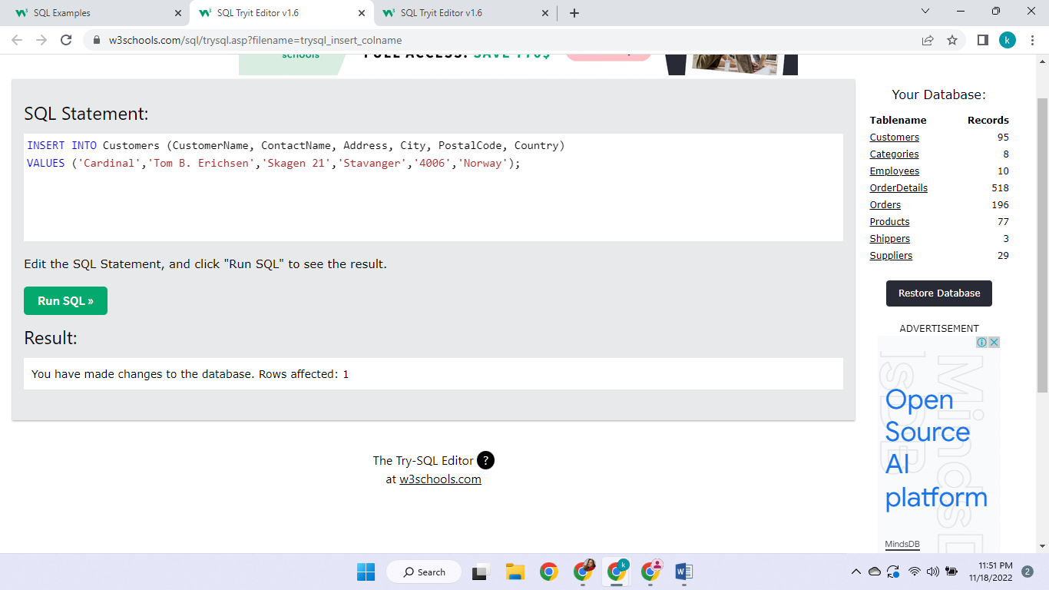

16. This is displaying the certain selected columns where the address value is empty
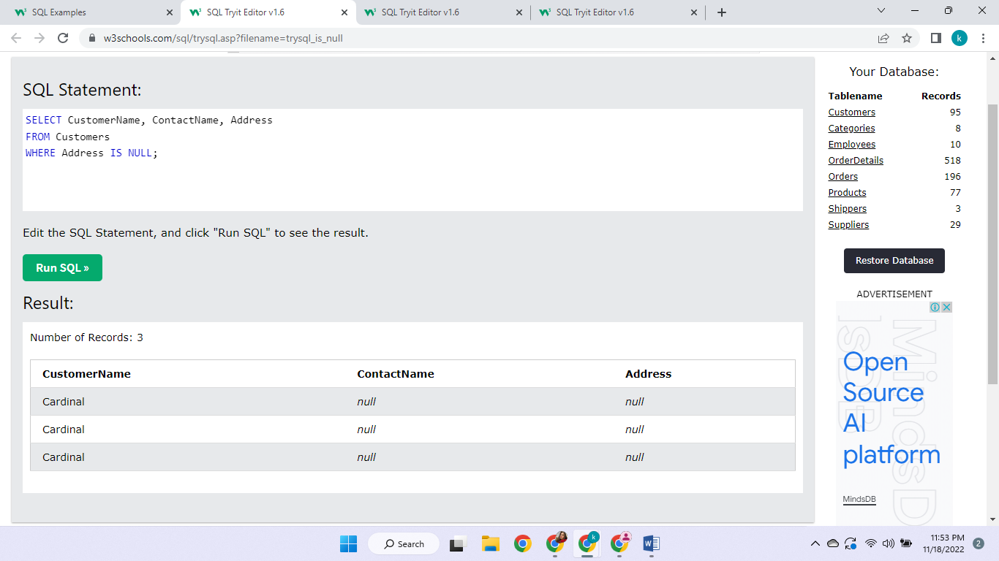

17. This is displaying the certain selected columns where the address value is not empty
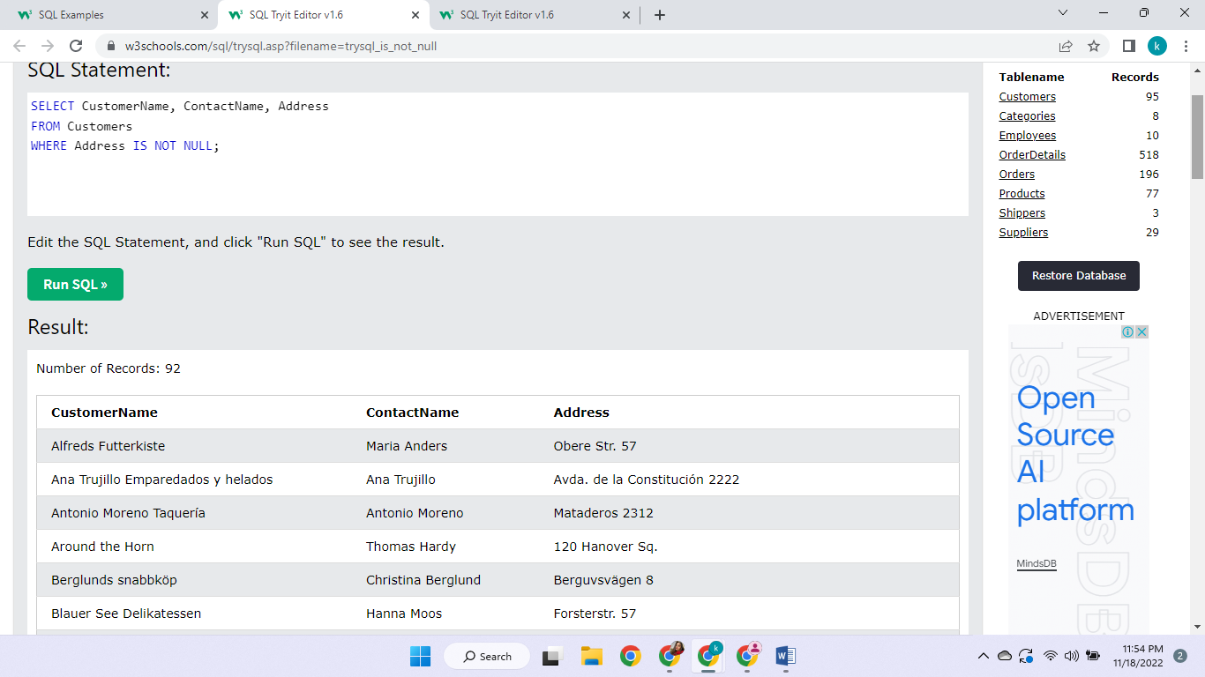

18. This is changing/updating the values in the previous record where the customer id is 1 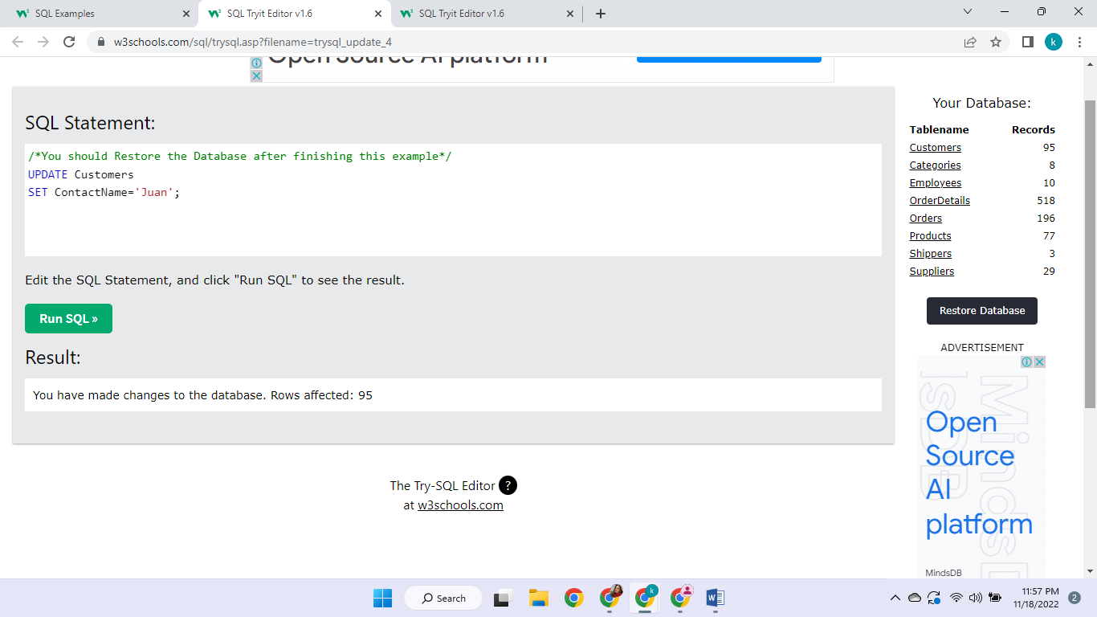

19. This is updating the entire database, changing every contact name

20. This deletes all the customer entries
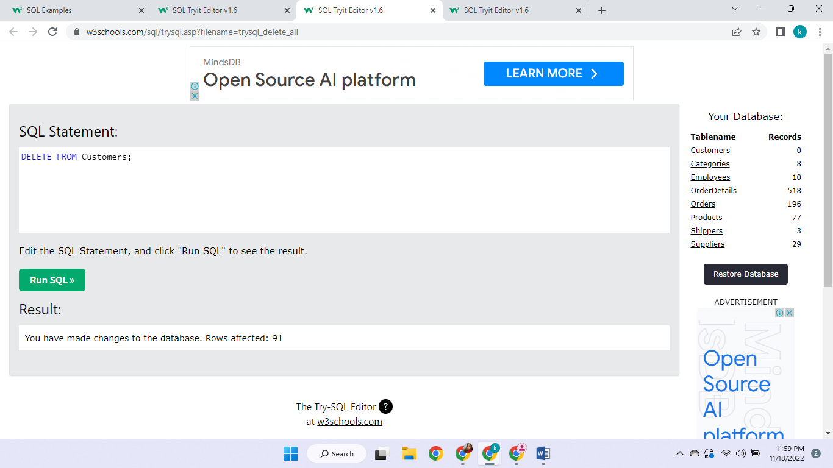

21. This deletes that entry where the name is alfreds
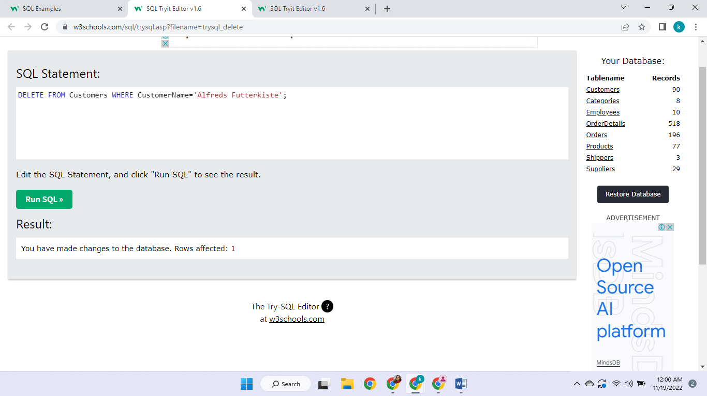

22. This selects the top 3 entries according to customer id
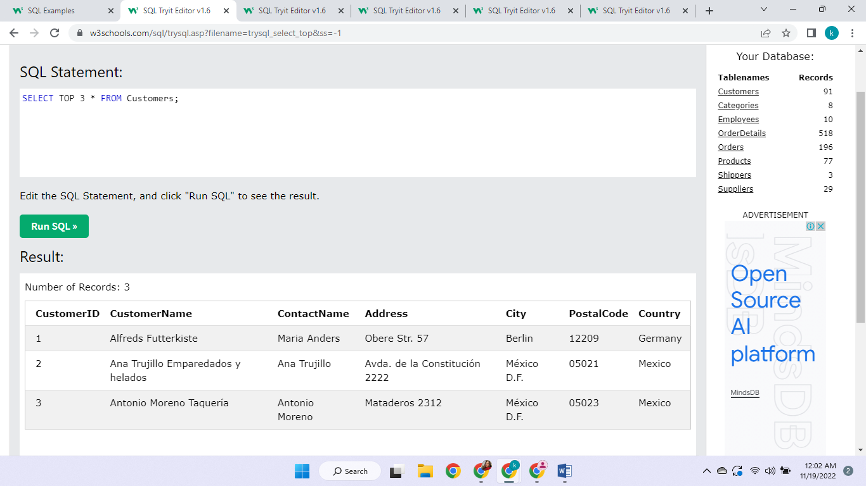

23. This is showing the all the top rows ; top half of the entire database
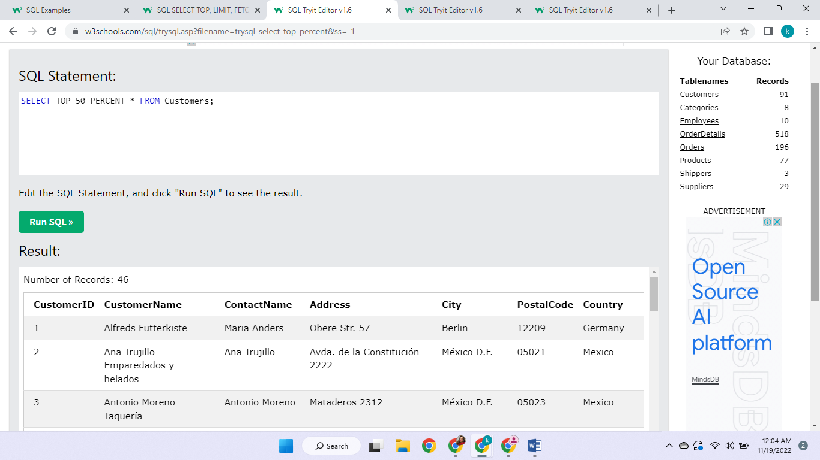

24. This is showing top 3 values of the condition that country is germany
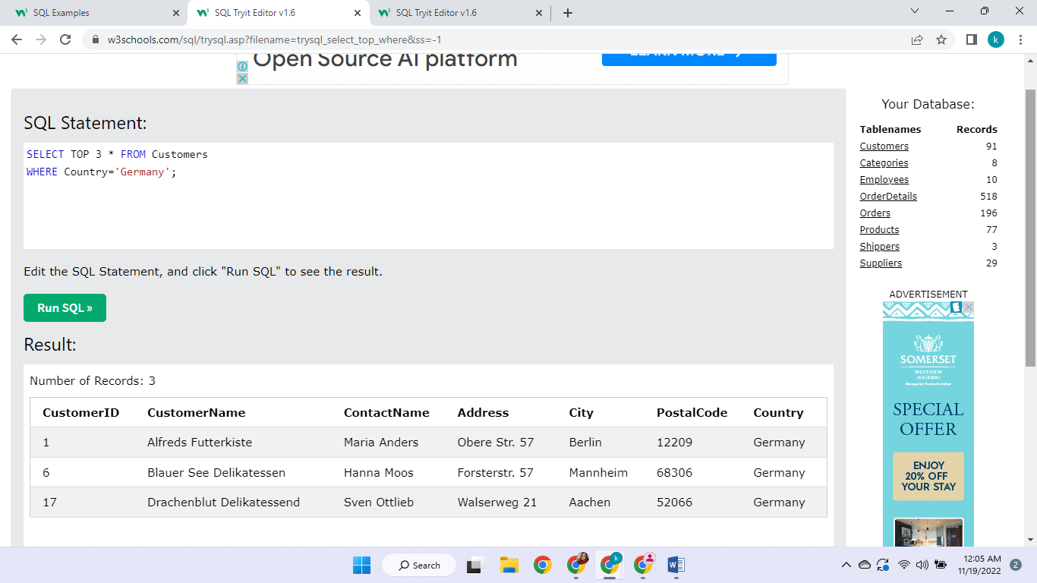

25. This is displaying the entry that has the smallest price in the database
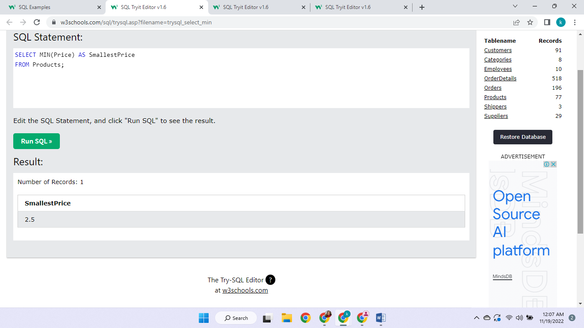

26. This is displaying the entry that has the highest price in the database
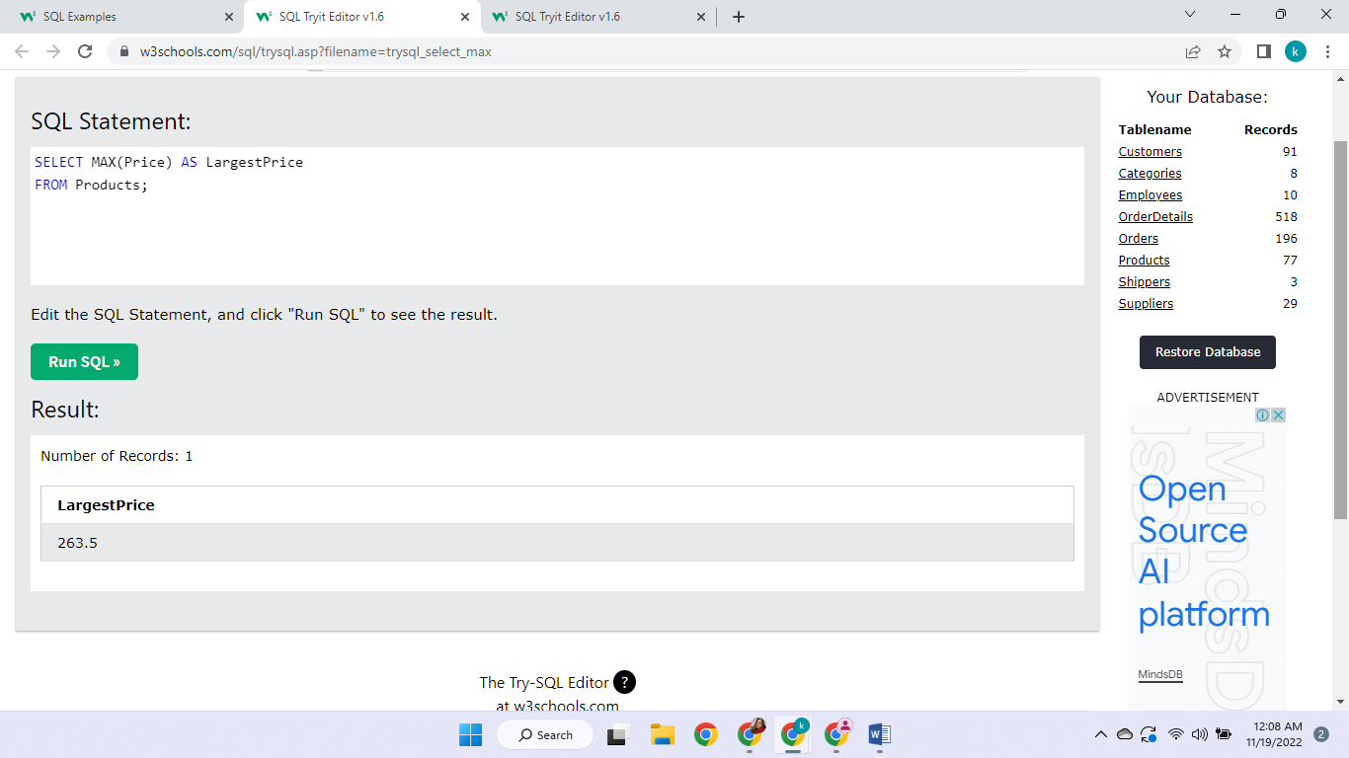

27. This displays how many records are in the database
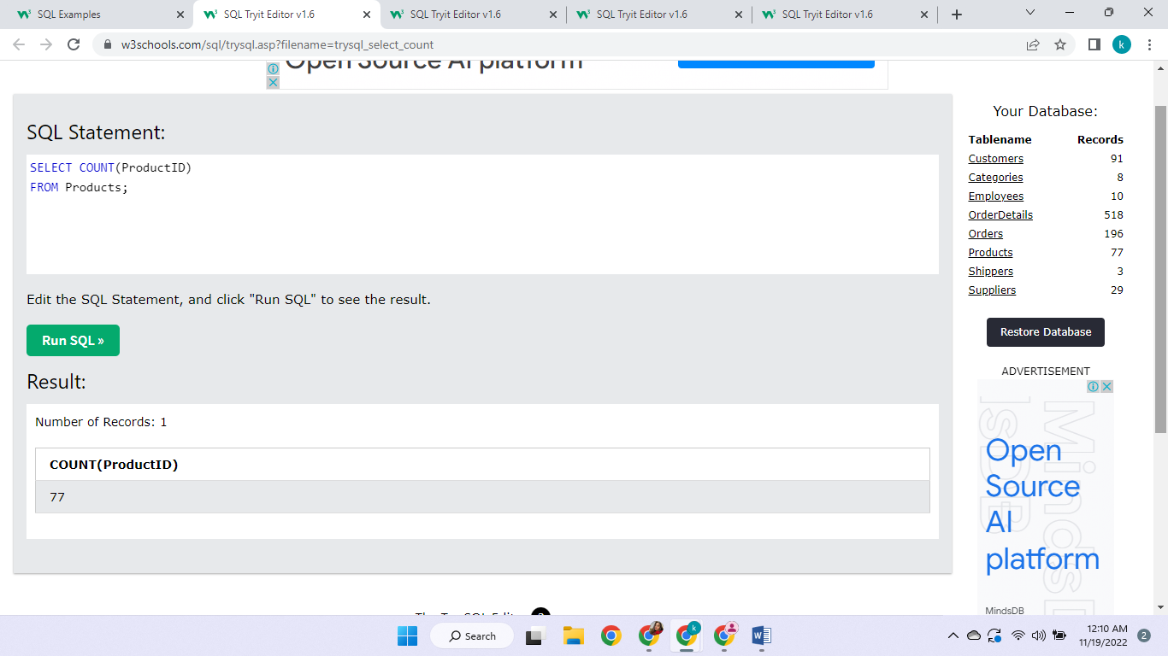

28. This sums up and averages up the price column
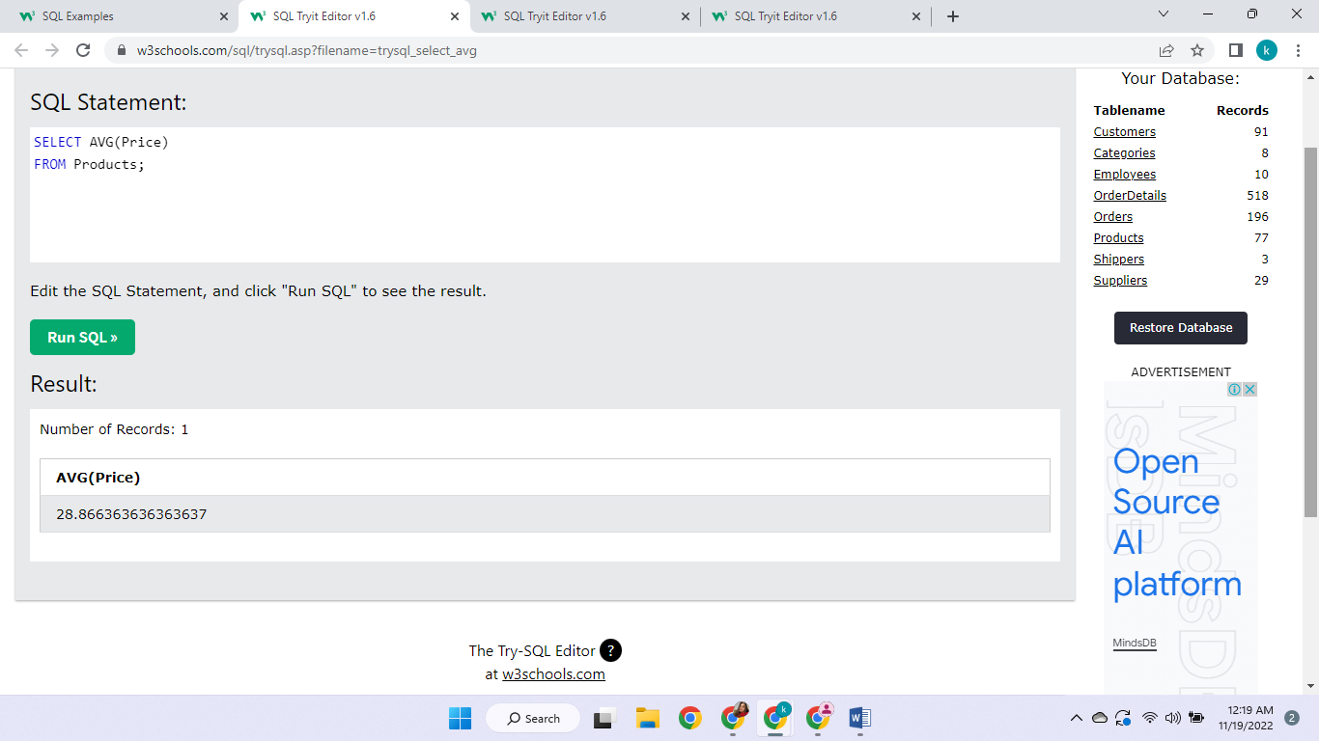

29. This adds up all the values from quantity column
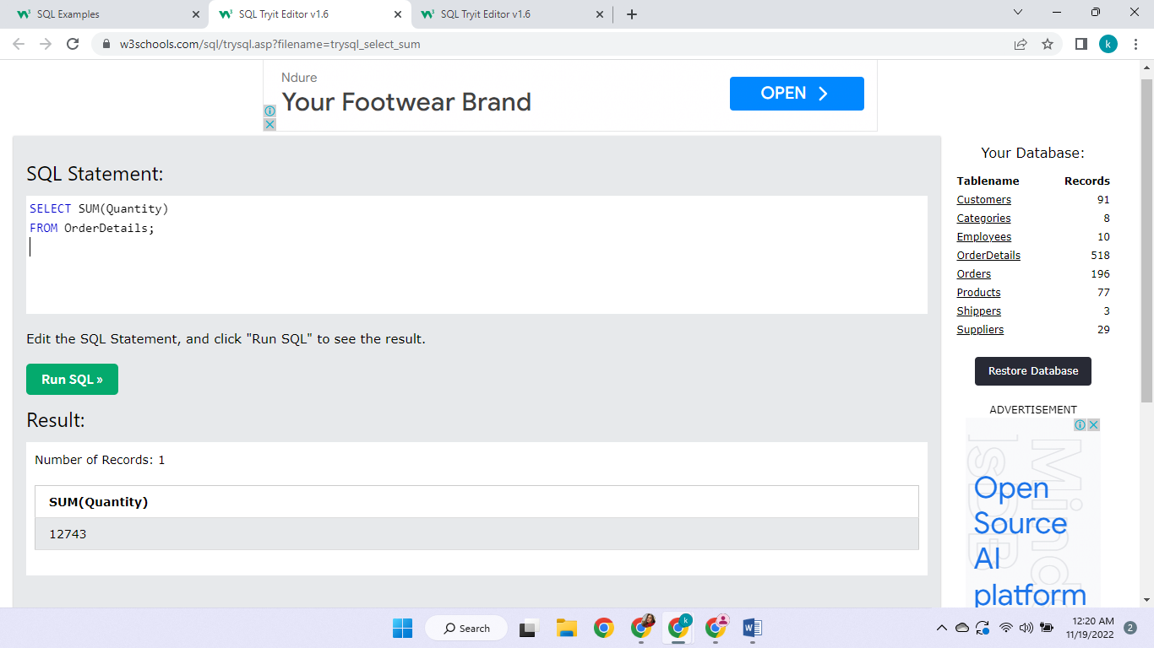

30. List entries in which the customer name starts with a
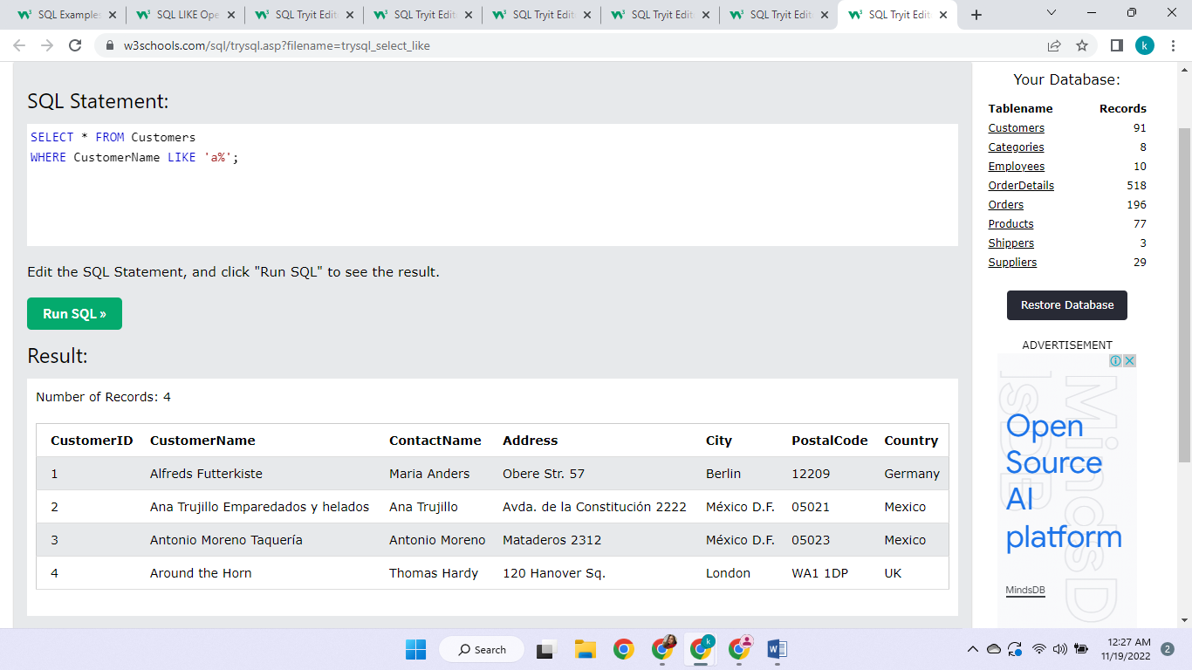

31. List entries in which the customer name ends with a
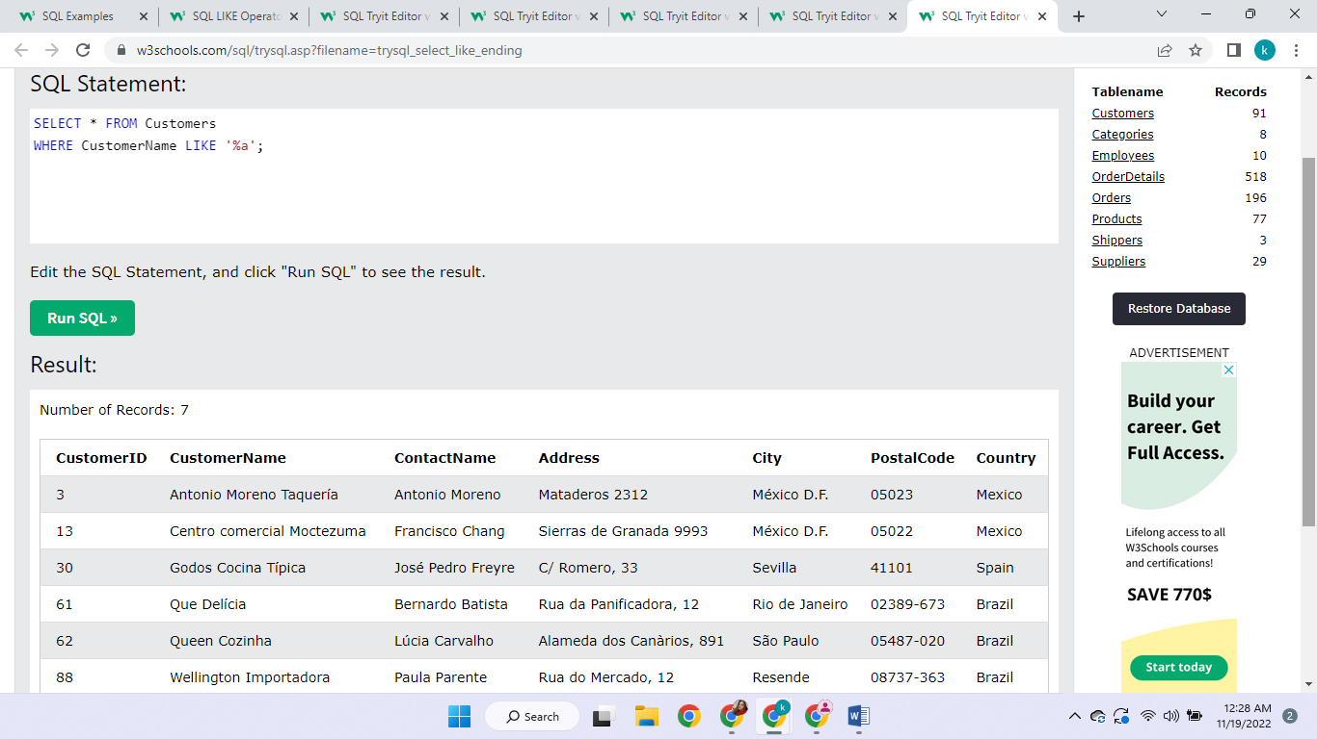

32. This will find all values that have ‘or’ in any position of the customer name 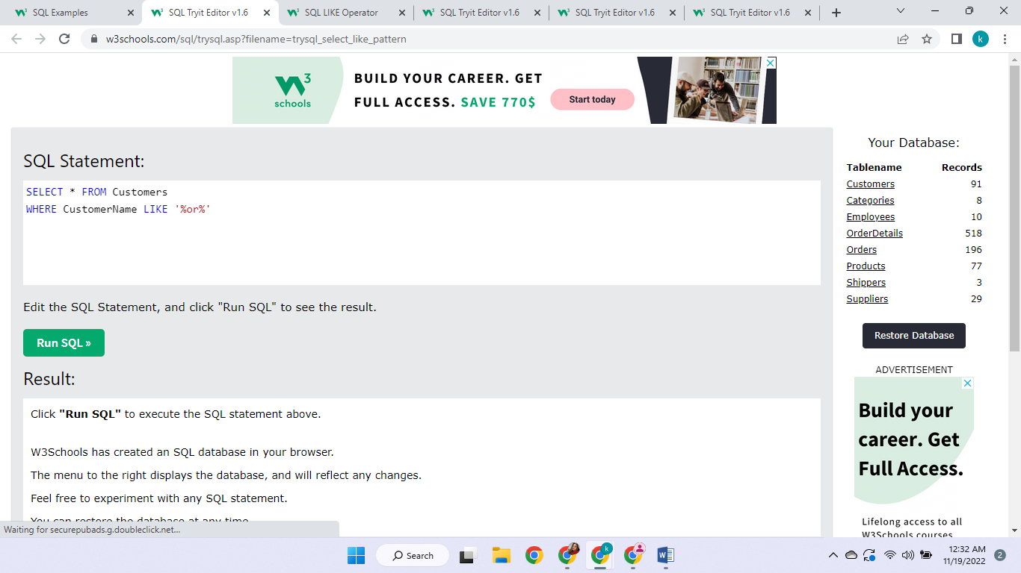

33. This will find all values that have ‘r’ in second position of the customer name
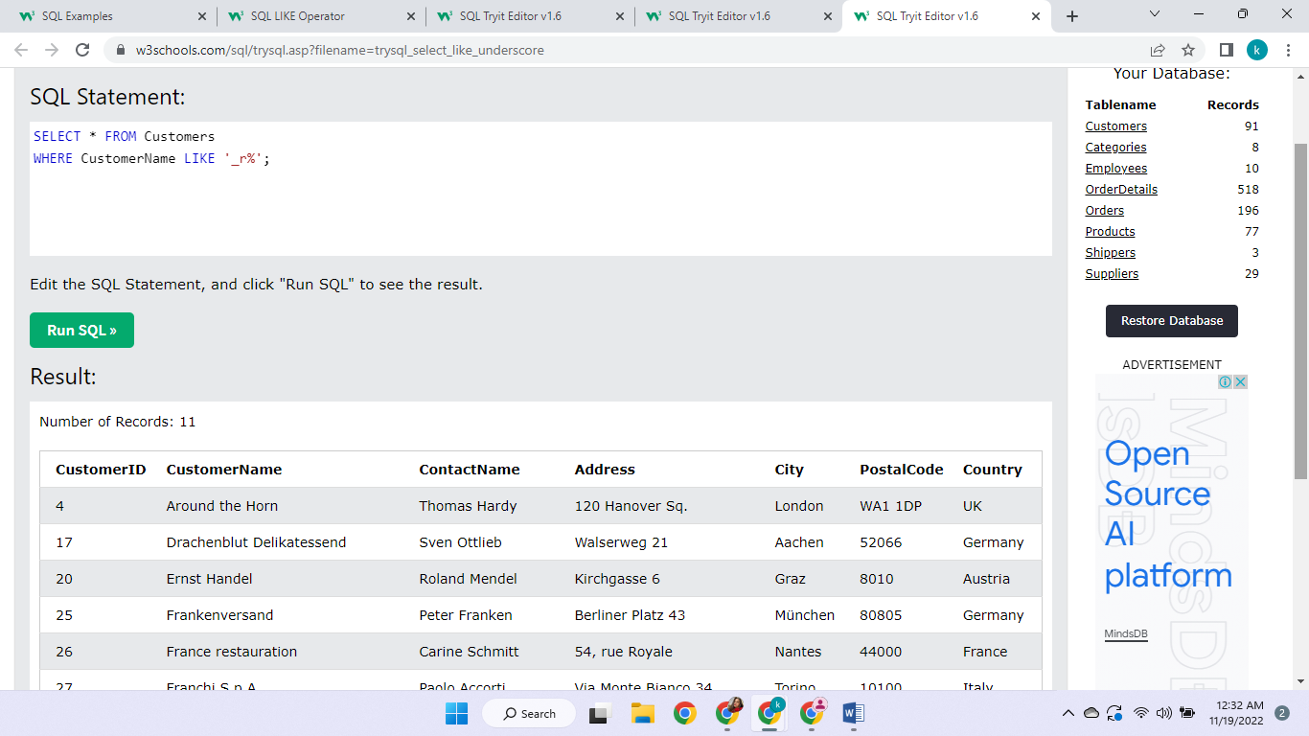

34. In this the contact name should start with a and end with o
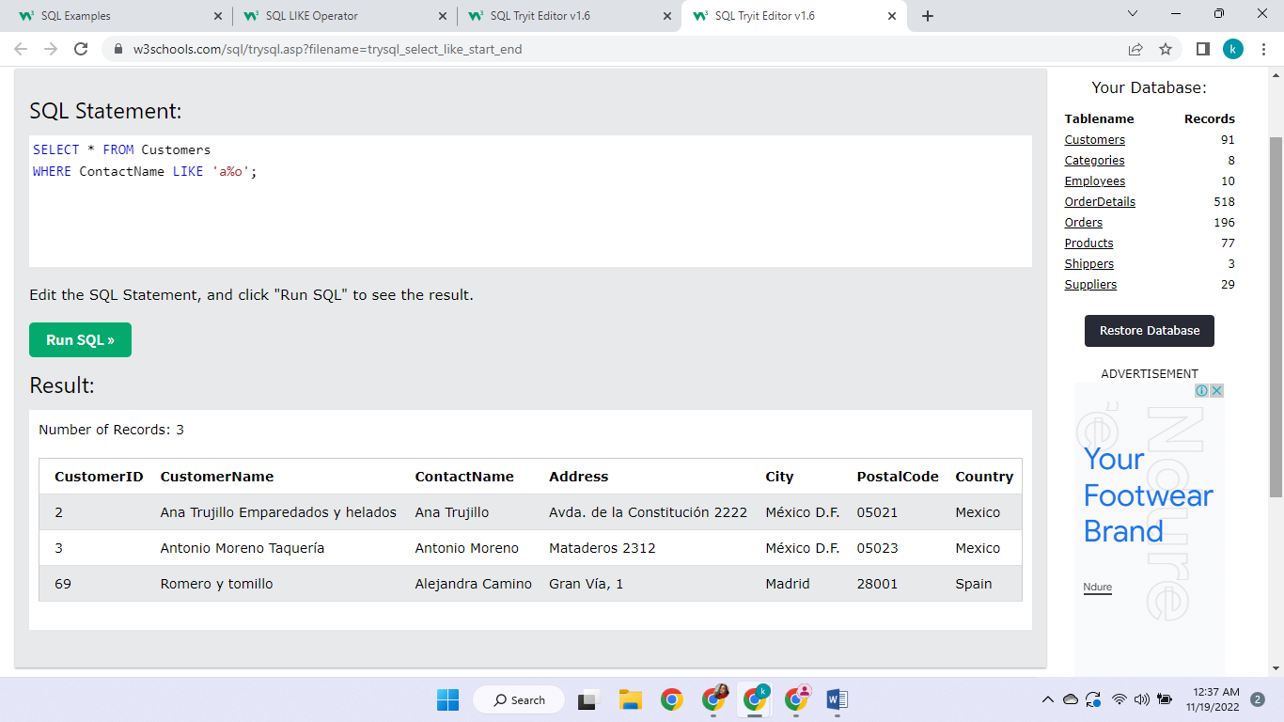

35. This selects all the rows in which the customer name does not start with a
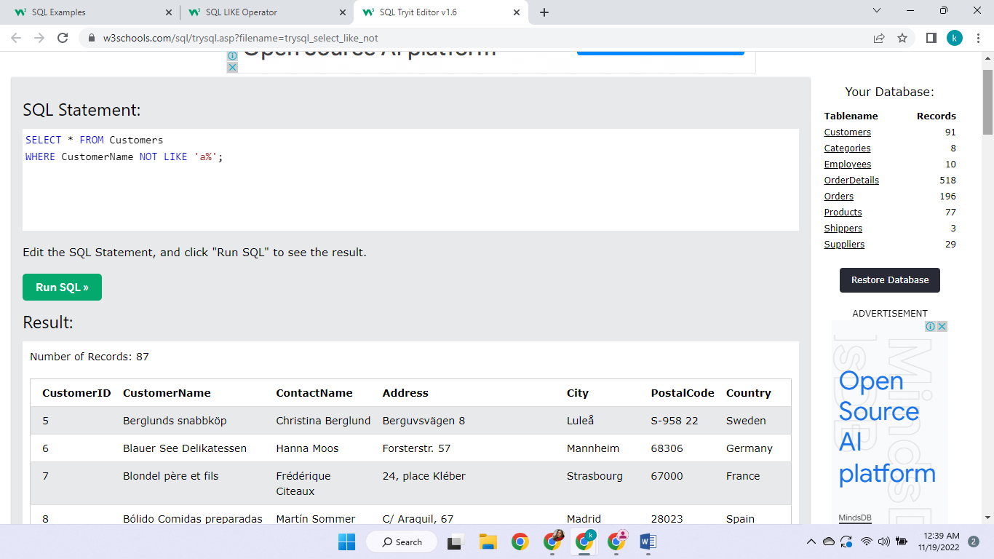

36. This selects all the rows in which the city name starts with ‘ber’
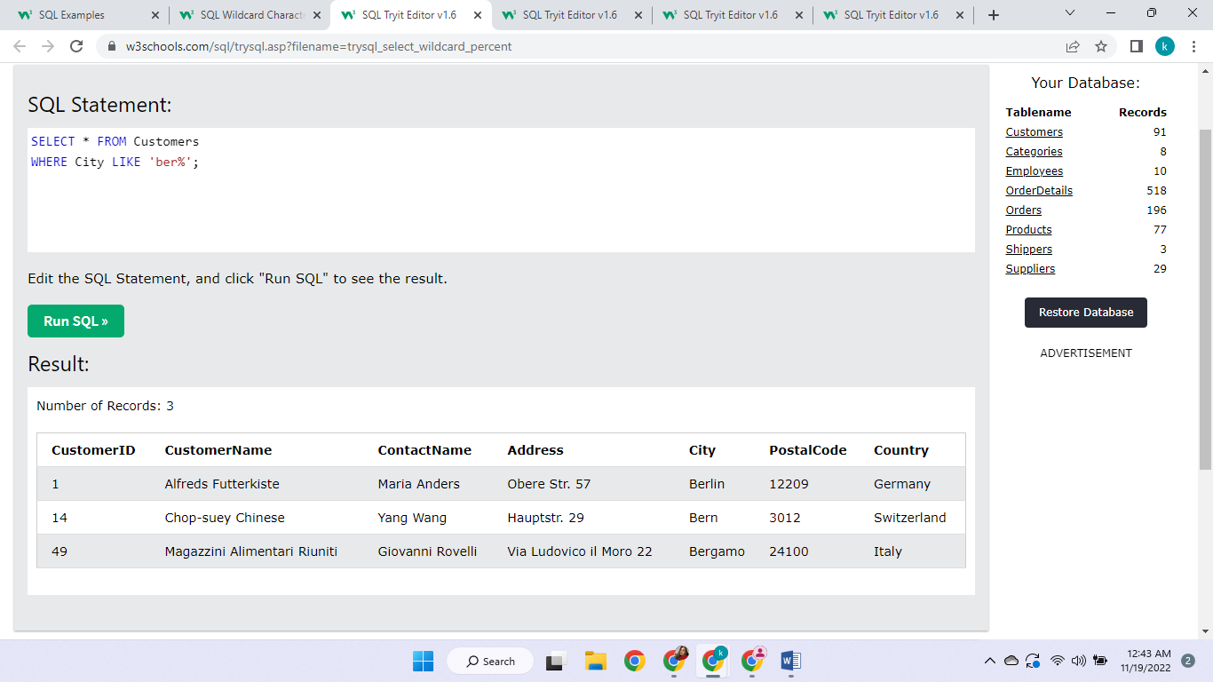

37. displays the entries where city ends in ‘ondon’
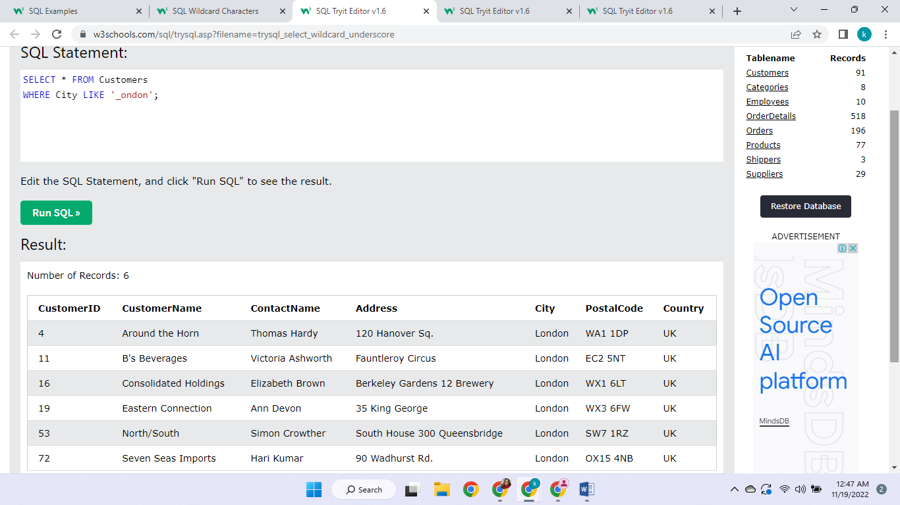

38. displays the entries where city starts with b, s or p
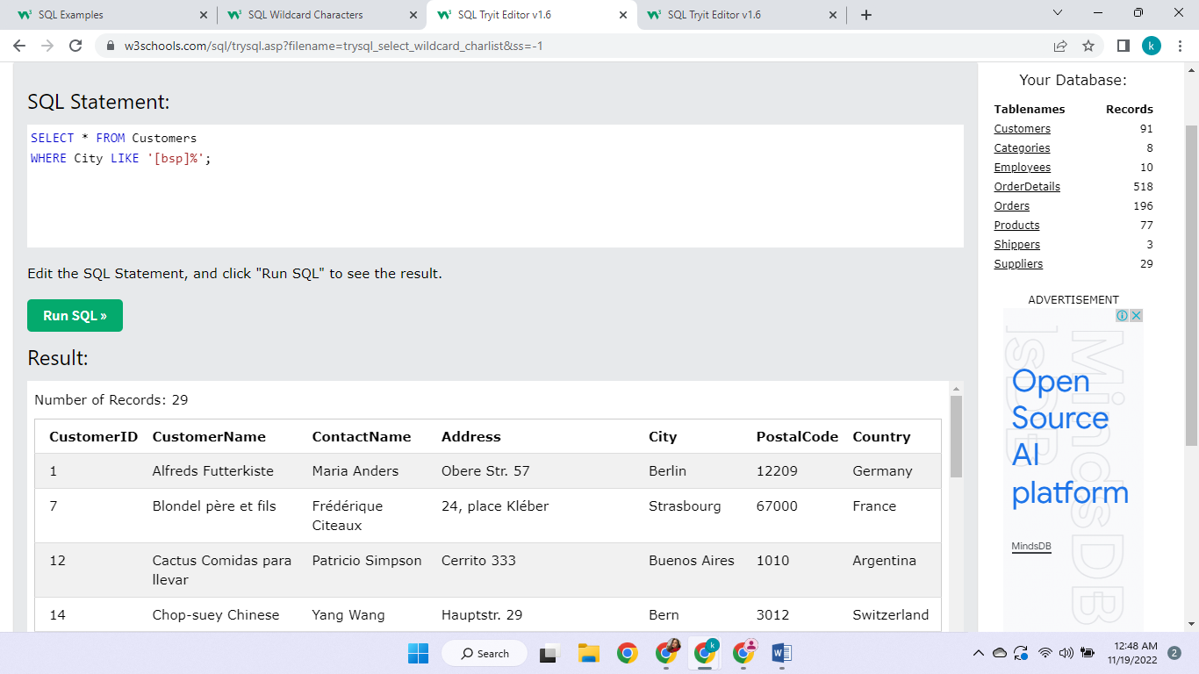

39. displays all the entries except in where the city starts with b, s or p
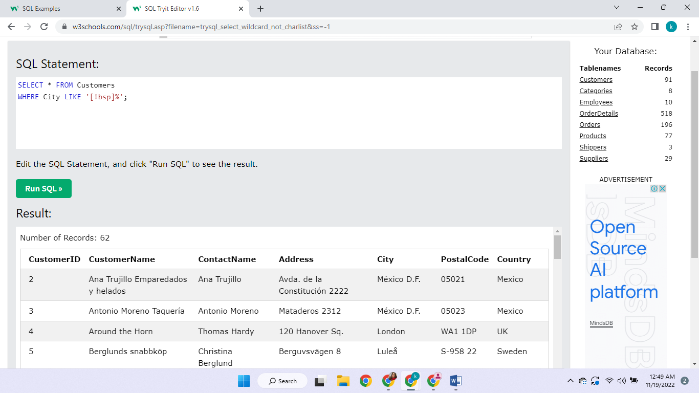

40. This acts like a OR statement so this one shows all entries in which country is germany or France or uk. We can select multiple or choices
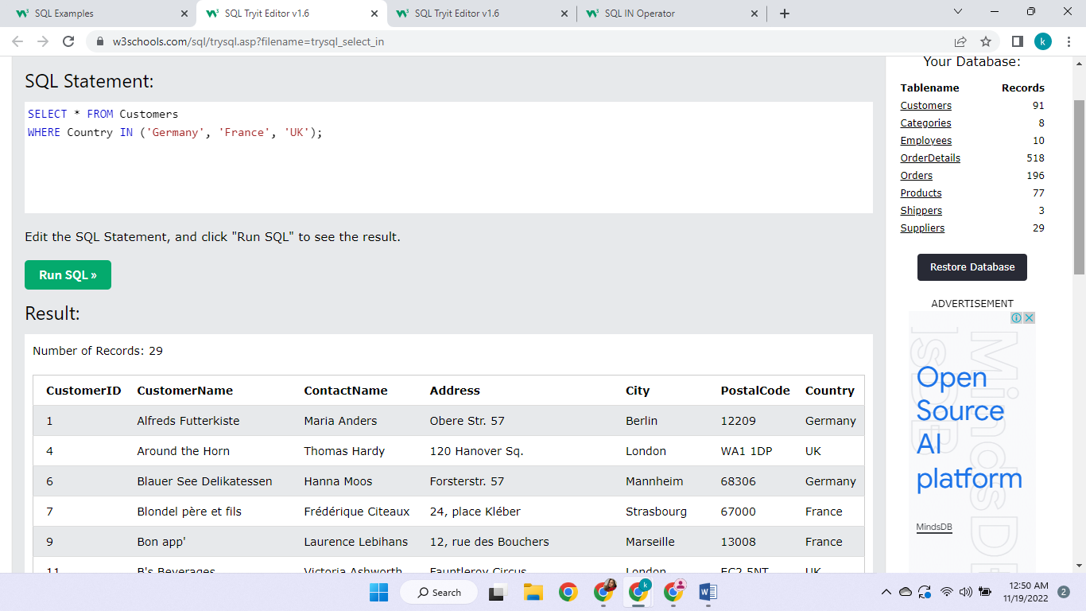

41 . This acts like an opposite of OR statement so this one shows all entries except in which country is germany or France or uk.
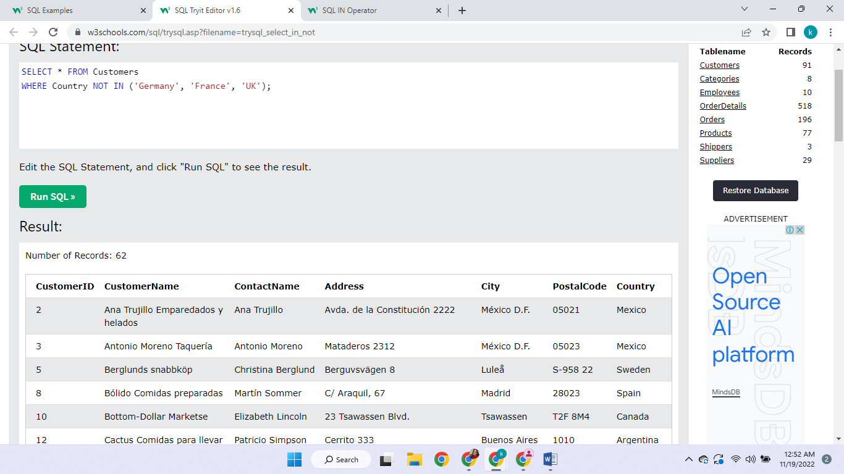

42. This is giving a price range to the price column that it should be from 10 to 20
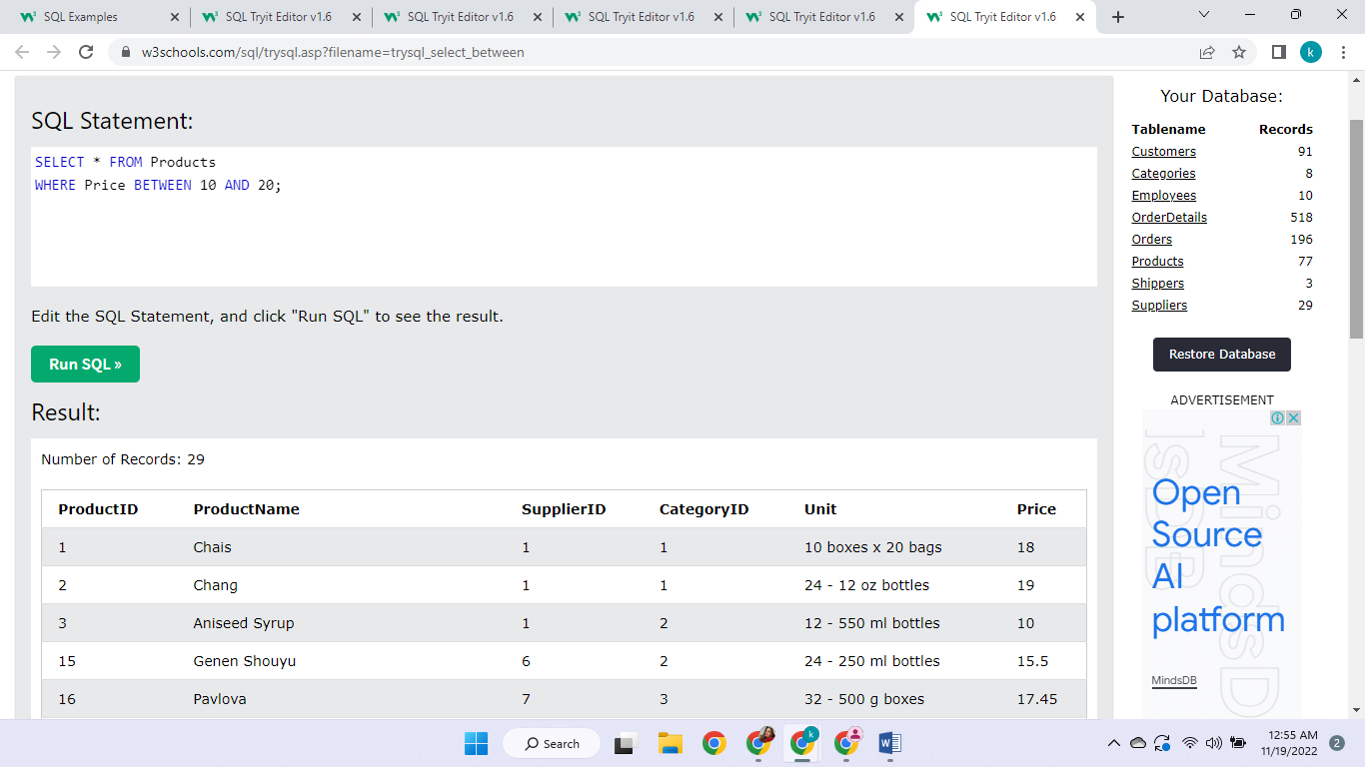

43. This is excluding the range 10 to 20 from the price column
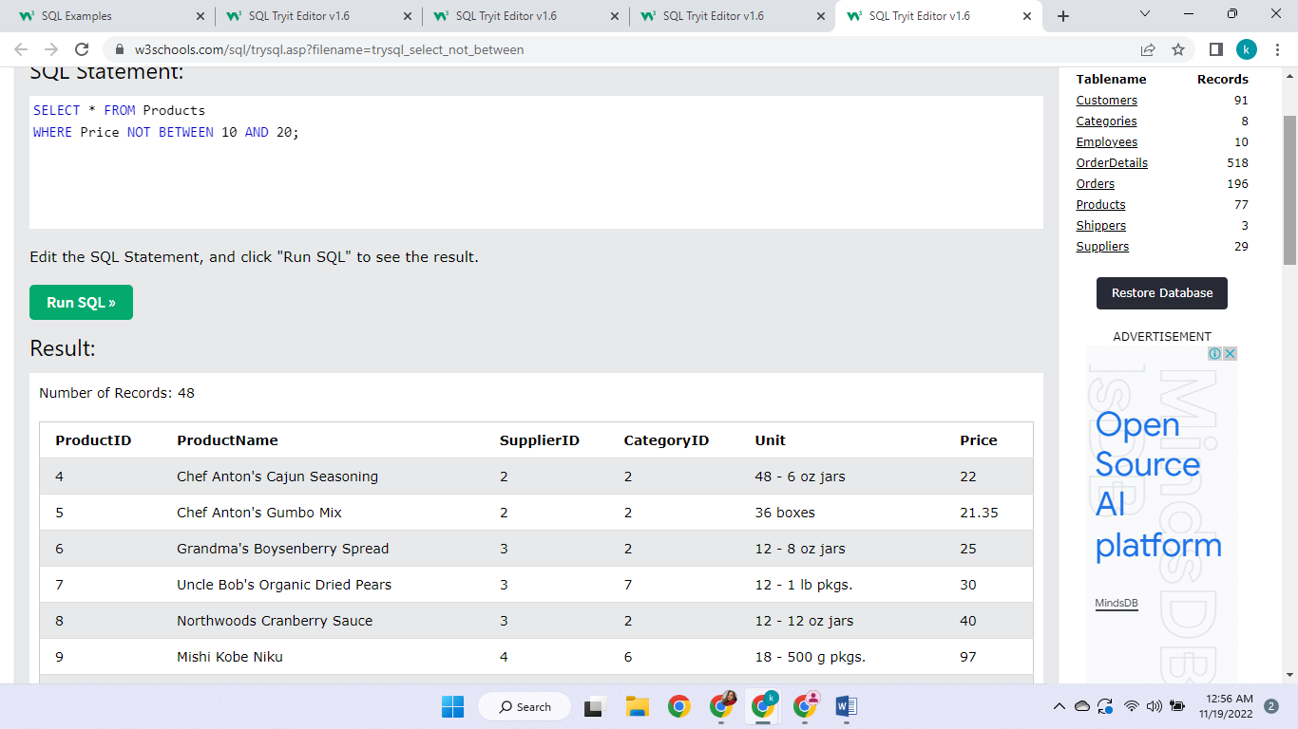

44. This changes the field name to the one mentioned
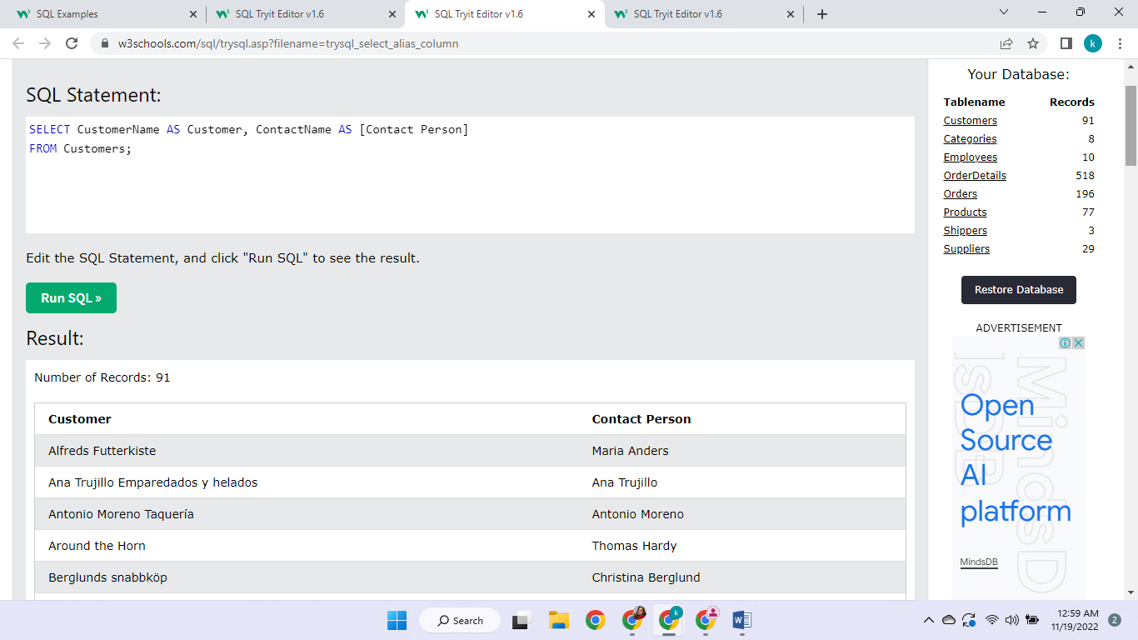

45. This is showing fields between two tables. Orders and Customers. It is displaying two fields
And matching customer ids which are present in both table.
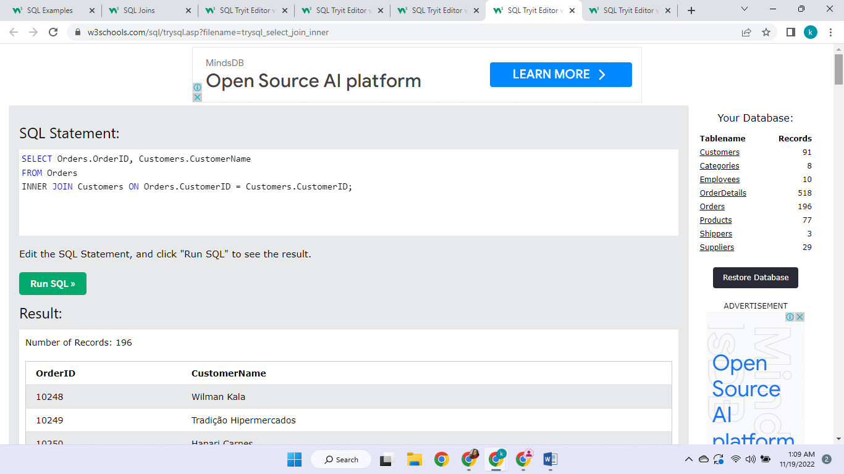

46. This is combining two fields of two tables and displaying them in ascending order only once
So it shows all different values
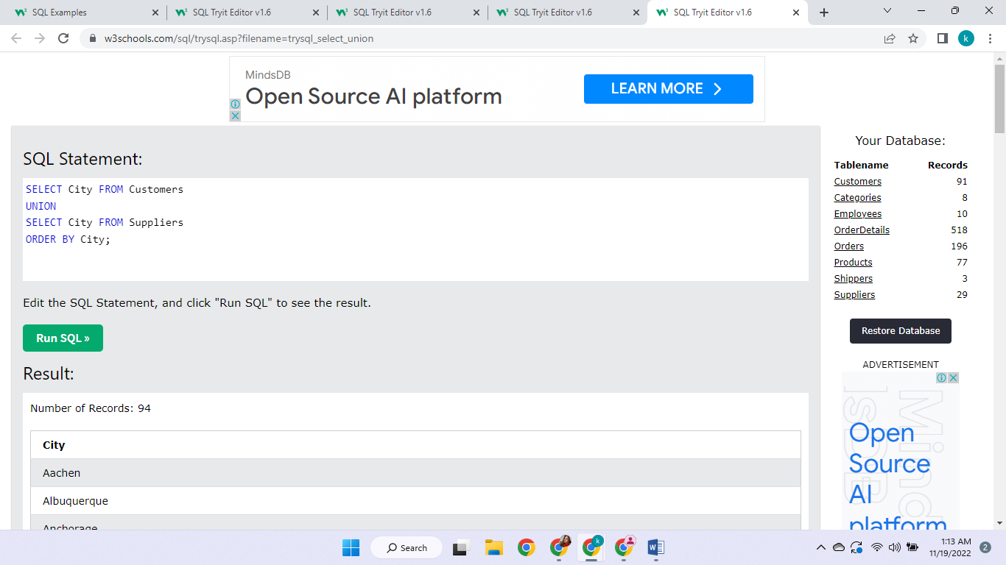
47. This is combining two fields of two tables and displaying them in ascending order
So it shows all values with repetition
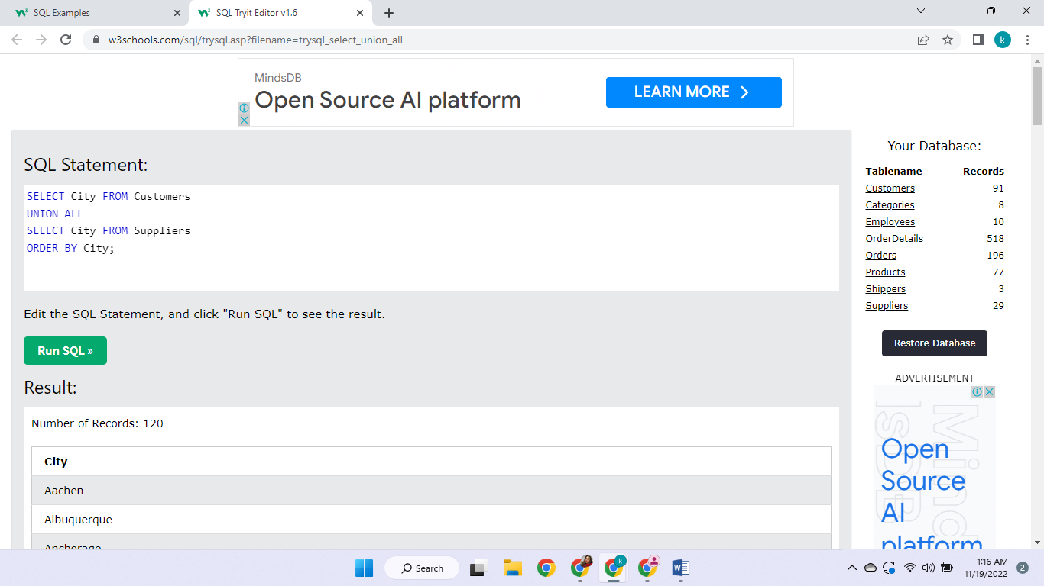

48.
This is grouping all the customers and summing up them according to the country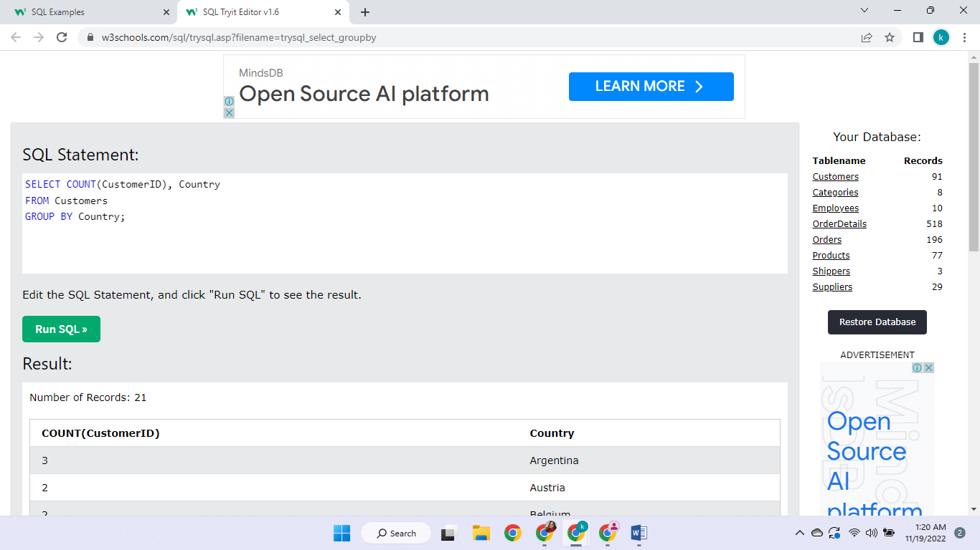
49. This is combined grouping and having
Same as grouping but it will only display is the count is above 5
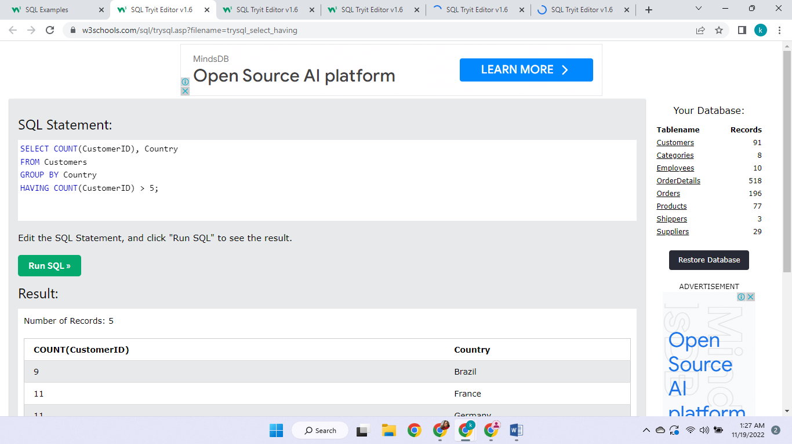

50. This tests for existence of the records where all the conditions are met
